**EXPLORING JAVA SPRING XML CONFIGURATION**

Get the example of **content schema** from this link:

<https://docs.spring.io/spring-framework/docs/4.2.x/spring-framework-reference/html/xsd-configuration.html>

<?xml version="1.0" encoding="UTF-8"?>

<beans xmlns="http://www.springframework.org/schema/beans"

    xmlns:xsi="http://www.w3.org/2001/XMLSchema-instance"

    xmlns:context="http://www.springframework.org/schema/context" xsi:schemaLocation="

        http://www.springframework.org/schema/beans http://www.springframework.org/schema/beans/spring-beans.xsd

        http://www.springframework.org/schema/context http://www.springframework.org/schema/context/spring-context.xsd">

</beans>

We can define the beans here also. And we can use this XML file to create spring context using the instance of the class ClassPathXmlApplicationContext.

Let’s create the XML file and define some bean,

We should create the XML file in **src/main/resources**.

**contextConfiguration.xml**

<?xml version="1.0" encoding="UTF-8"?>

<beans xmlns="http://www.springframework.org/schema/beans"

    xmlns:xsi="http://www.w3.org/2001/XMLSchema-instance"

    xmlns:context="http://www.springframework.org/schema/context" xsi:schemaLocation="

        http://www.springframework.org/schema/beans http://www.springframework.org/schema/beans/spring-beans.xsd

        http://www.springframework.org/schema/context http://www.springframework.org/schema/context/spring-context.xsd">

    <!-- bean definitions here -->

    <bean id = "name" class = "java.lang.String">

        <constructor-arg value = "Naveen" />

    </bean>

    <bean id = "age" class = "java.lang.Integer">

        <constructor-arg value = "21" />

    </bean>

</beans>

id 🡪 Bean name.

class 🡪 for return type.

value 🡪 the value the bean going to return.

**SpringXML_ConfigApp.java**

package com.naveen.learnspringframework.SpringXMLConfigExample;

import java.util.Arrays;

import org.springframework.context.support.ClassPathXmlApplicationContext;

public class SpringXML_ConfigApp {

    public static void main(String[] args) {

        try(var context =

                new ClassPathXmlApplicationContext

                        ("contextConfiguration.xml")){

            Arrays.stream(context.getBeanDefinitionNames())

                .forEach(System.out::println);

            System.out.println(context.getBean("name"));

        }

    }

}

**OUTPUT:**

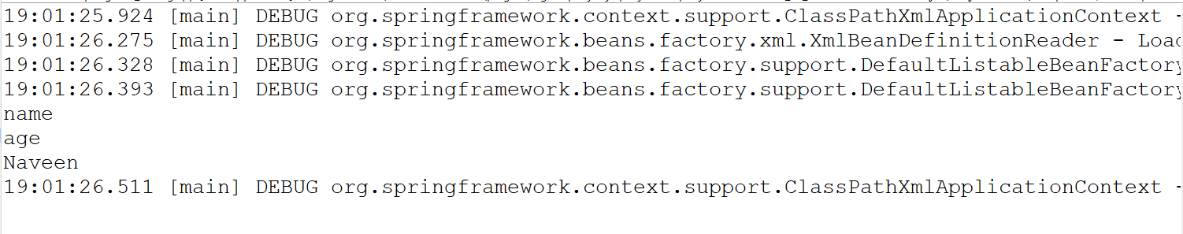

We can scan the component in the other packages and use it in our XML configuration.

**contextConfiguration.xml**

<?xml version="1.0" encoding="UTF-8"?>

<beans xmlns="http://www.springframework.org/schema/beans"

    xmlns:xsi="http://www.w3.org/2001/XMLSchema-instance"

    xmlns:context="http://www.springframework.org/schema/context" xsi:schemaLocation="

        http://www.springframework.org/schema/beans http://www.springframework.org/schema/beans/spring-beans.xsd

        http://www.springframework.org/schema/context http://www.springframework.org/schema/context/spring-context.xsd">

<!-- bean definitions here -->

    <bean id = "name" class = "java.lang.String">

        <constructor-arg value = "Naveen" />

    </bean>

    <bean id = "age" class = "java.lang.Integer">

        <constructor-arg value = "21" />

    </bean>

    <context:component-scan

        base-package="com.naveen.learnspringframework.LazyAndEagerInitialization"/>

</beans>

**OUTPUT:**

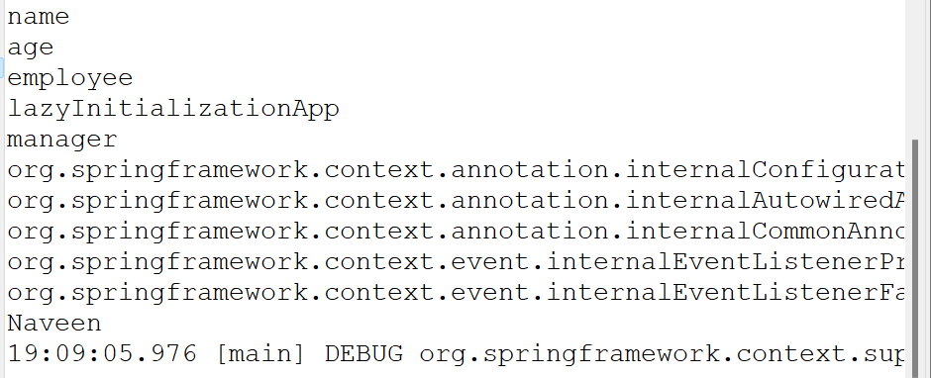

**contextConfiguration.xml**

<?xml version="1.0" encoding="UTF-8"?>

<beans xmlns="http://www.springframework.org/schema/beans"

    xmlns:xsi="http://www.w3.org/2001/XMLSchema-instance"

    xmlns:context="http://www.springframework.org/schema/context" xsi:schemaLocation="

        http://www.springframework.org/schema/beans http://www.springframework.org/schema/beans/spring-beans.xsd

        http://www.springframework.org/schema/context http://www.springframework.org/schema/context/spring-context.xsd"> <!-- bean definitions here -->

    <bean id = "name" class = "java.lang.String">

        <constructor-arg value = "Naveen" />

    </bean>

    <bean id = "age" class = "java.lang.Integer">

        <constructor-arg value = "21" />

    </bean>

    <context:component-scan

        base-package="com.naveen.learnspringframework.LazyAndEagerInitialization"/>

    <bean id = "game" class = "com.naveen.learnspringframework.game.PacmanGame"/>

    <bean

        id = "gameRunner"

        class = "com.naveen.learnspringframework.game.GameRunner">

        <constructor-arg ref = "game"/>

    </bean>

</beans>

**SpringXML_ConfigApp.java**

package com.naveen.learnspringframework.SpringXMLConfigExample;

import java.util.Arrays;

import org.springframework.context.support.ClassPathXmlApplicationContext;

import com.naveen.learnspringframework.game.GameRunner;

public class SpringXML_ConfigApp {

    public static void main(String[] args) {

        try(var context =

                new ClassPathXmlApplicationContext

                        ("contextConfiguration.xml")){

            Arrays.stream(context.getBeanDefinitionNames())

                .forEach(System.out::println);

            System.out.println(context.getBean("name"));

            context.getBean(GameRunner.class).run();

        }

    }

}

OUTPUT:

